Project Documentation

**MP1 – School of Law Website**

CMS used:

* WordPress

Available Features:

* Theme System – provides the extensibility to create themes as simple or as complex as per the user’s needs and wants.
* Customizing through Panel – all editing and customization tools, and settings are available on the panel for easy access in customizing the website.
* Media Management with Image Optimization– to be able to quickly and easily upload images and media to WordPress. Drag and drop Medias into the uploader to add it to the website or for future reference and use. Add alt text, captions, and titles, and insert images and galleries into the content.
* Publishing Tools – also for easier management of the content. Create drafts and schedule publication.
* Plug-in System – a piece of software containing a group of functions that can be added to a WordPress website. They can extend functionality or add new features to the WordPress websites.
* Multi-user capability – when relying on multiple people to keep your site up and running. WordPress has a feature that assigns and let you have a variety of contributors to the website. Here is a summary of these roles from WordPress User Management:
* Administrator – somebody who has access to all the administration features within a single site.
* Editor – somebody who can publish and manage posts including the posts of other users.
* Author – somebody who can publish and manage their own posts.
* Contributor – somebody who can write and manage their own posts but cannot publish them.
* Subscriber – somebody who can only manage their profile.

Implementation of the CMS features:

* Theme System – the WordPress provides varieties of themes and it is categorized in varieties like business entrepreneur themes, blog themes, gallery theme, university theme, and others. The theme used by the group is a University theme, of course, to suit the school website.
* Customizing Through Panel – the customizing tools are available on the Customizing Panel which is located on the left side of the window when editing the site. This feature enables us to access the tools easier.
* Media Management with Image Optimization – the group uploaded images that are to be used in the website in which it can be resized and cropped without the use of 3rd party software. This feature enables us to upload images in the database without the need to access the images from other computers. Then the images can be scalable and resized as said earlier
* Publishing tools – The WordPress has this publishing tool that enables us to input, edit and publish the contents that we are to put in the school website we are creating.
* Multi-user capability – The WordPress has this multi-user capability that has a variety of contributors to the school website that we are creating. We have one administrator who has the ability to access every feature of WordPress. He can manage and monitor the editors on what they are editing in the website. We also have 4 editors who are the one that puts contents, news and events that are being uploaded and published in our school website. The author on the other hand is the person who is in charge of their own published contents that will be uploaded as a content, news or event.
* Plug-in System – we extended the functionalities of our website by integrating a contact form plug-in that will be used for the Contact Us page, specifically in inquiring.

WordPress Plug-in used:

* Contact Form 7 – this plug-in form is for viewers who wish to ask inquiries or send feedbacks to the administrator.
* MapPress Easy Google Maps – this plug-in is helpful for viewers who are not familiar what road to be taken going to the university, where this plug-in show the map of Baguio City and where the university is located.

**MP2 – In-browser Offline Web Application**

Brief Description:

* Offline Attendance Tracker - an Offline Web Application that downloads the schedules of the faculty in SCIS to be used in checking of the attendance. The Application can also let the user view the records of each instructor based on the attendance.

Modules and the Implemented Functionalities:

* Schedule Downloader
  + Allows the user download the existing schedules of the faculty and saves it to the local storage to be able to access the data offline.
  + *startUI()*

- Function for creating all the elements in the dashboard. The webapp will ask you to download the schedules needed. As you click download it will get all the data of each schedules in the localstorage. Once the data has been downloaded a list of schedules will be created and if an error has occurred, an alert box will pop up containing an error message.

* Summary Viewer
  + Allows the user view the summarized report that he made in the current time.
  + *summary()*

- The function creates a table of all the recorded late and absences.

* Report Generation
  + Generates the report which is stored to the server and computes all late and absences that a particular instructor committed that is to be viewed by the user.
  + *retrieveReport()*

- This function gets the data from the server containing all the list of lates and absences recorded by the user. The function creates a list of all instructors, each of them containing all of their records of late and absences.

* Reset module
  + Resets and clears the local storage and data recorded by the user.
  + *reset()*

- The function will remove all the items stored in the localstorage.

* Attendance Checker
  + Allows the user check the attendance whether a specific instructor is late, absent or All present.
  + *seven() - five()*

- Creates a table containing the instructors that has a schedule on that time.

Function -- Time:

seven() -- 7:30-8:30

eight() -- 8:30-9:30

nine() -- 9:30-10:30

ten() -- 10:30-11:30

eleven() -- 11:30-12:30

twelve() -- 12:30-1:30

one() -- 1:30-2:30

two() -- 2:30-3:30

three() -- 3:30-4:30

four() -- 4:30-5:30

five() -- 5:30-6:30

The table has four columns the name of the instructor, room of the class he/she is attending, and two buttons naming absent and late to record if the instructor is late or absent, respectively.

* Data Sender
  + Allows the user to send the current recorded data to the server for future use such as generating a report.
  + sync()
    - Sync all the recorded late and absences to the server.

HTML5 Features Used:

* XmlHttpRequest
* Local Storage
* Application Storage

Implementation of the HTML5 Features:

* XmlHttpRequest - Using this feature lets the user download the current schedule of the faculty. It also appends and retrieves recorded data to the server such as absents and lates of specific instructor.
* Local Storage - the implementation of this feature is used by storing the schedules of the instructors to later on be parsed as a JSON object, save Button checkers are also stored in the Local storage for the user to know whether he already checked a specific set of schedules. The absent and late are also stored in the local storage to be appended in the future however, this will be cleared when the user appends the data in the server or clicked on the reset button.
* Application Storage - this feature makes the web application accessible even when the servers are not running. However, some features like the XMLHttpRequest will not function when not online.

Screenshots of the School Website:

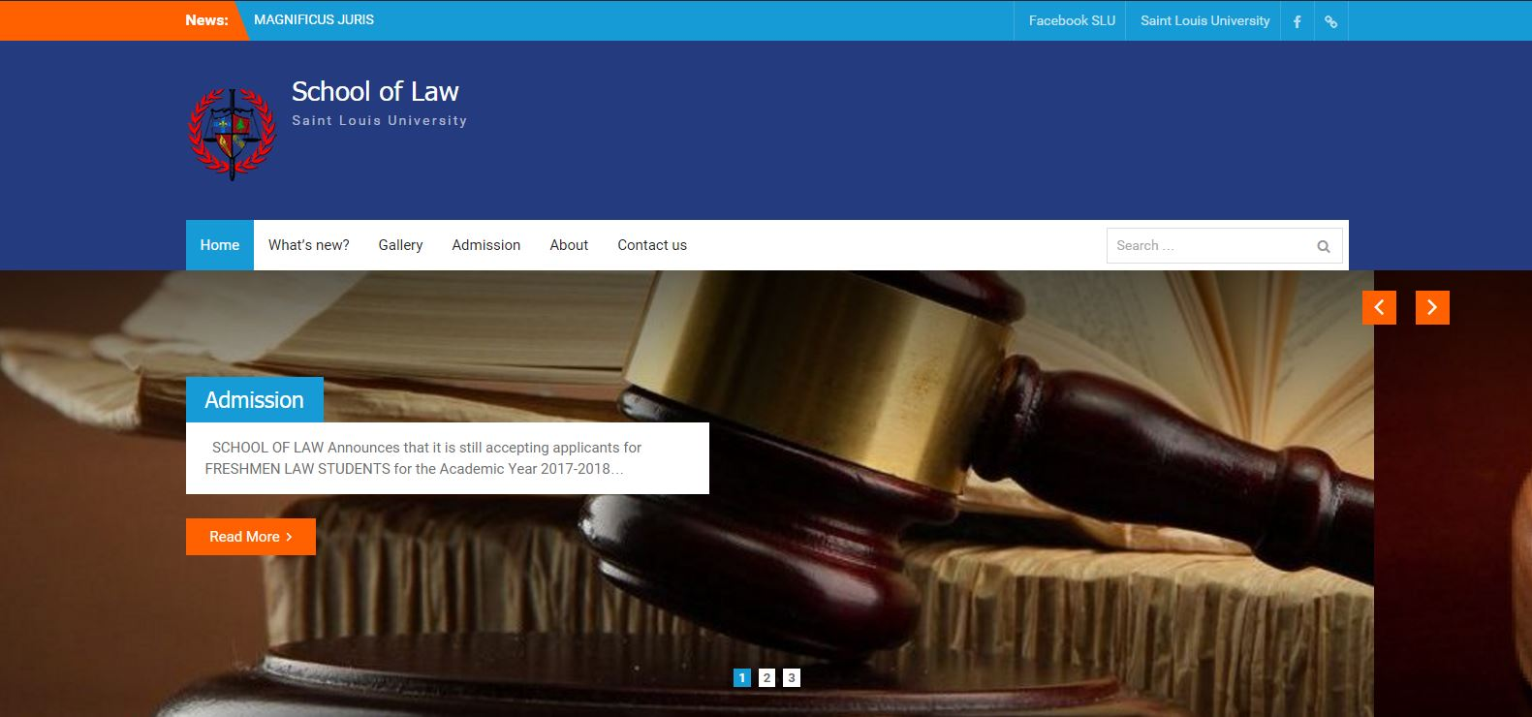

Figure 1. Home page of the website

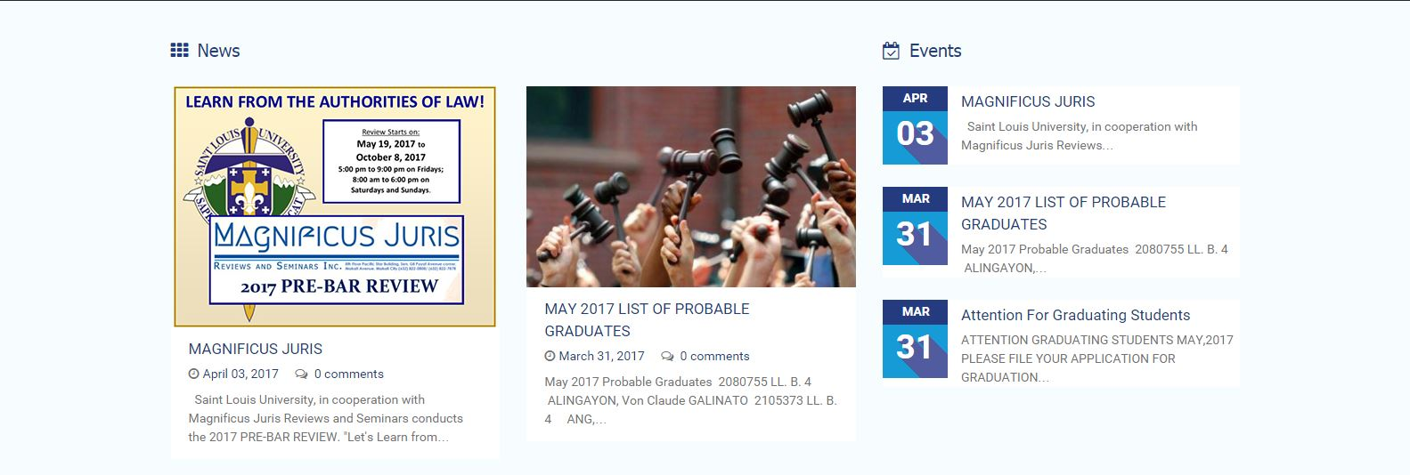

Figure 2. Middle part of the Home page.

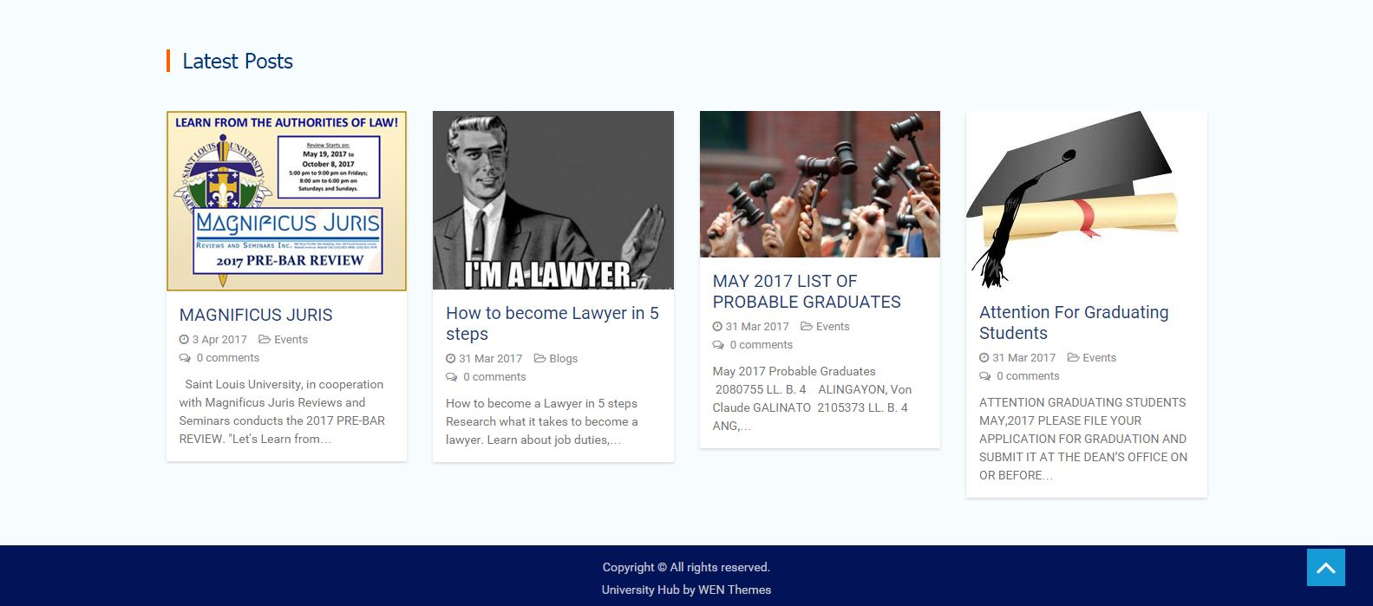

Figure 3. Lower part of the home page including the footer.

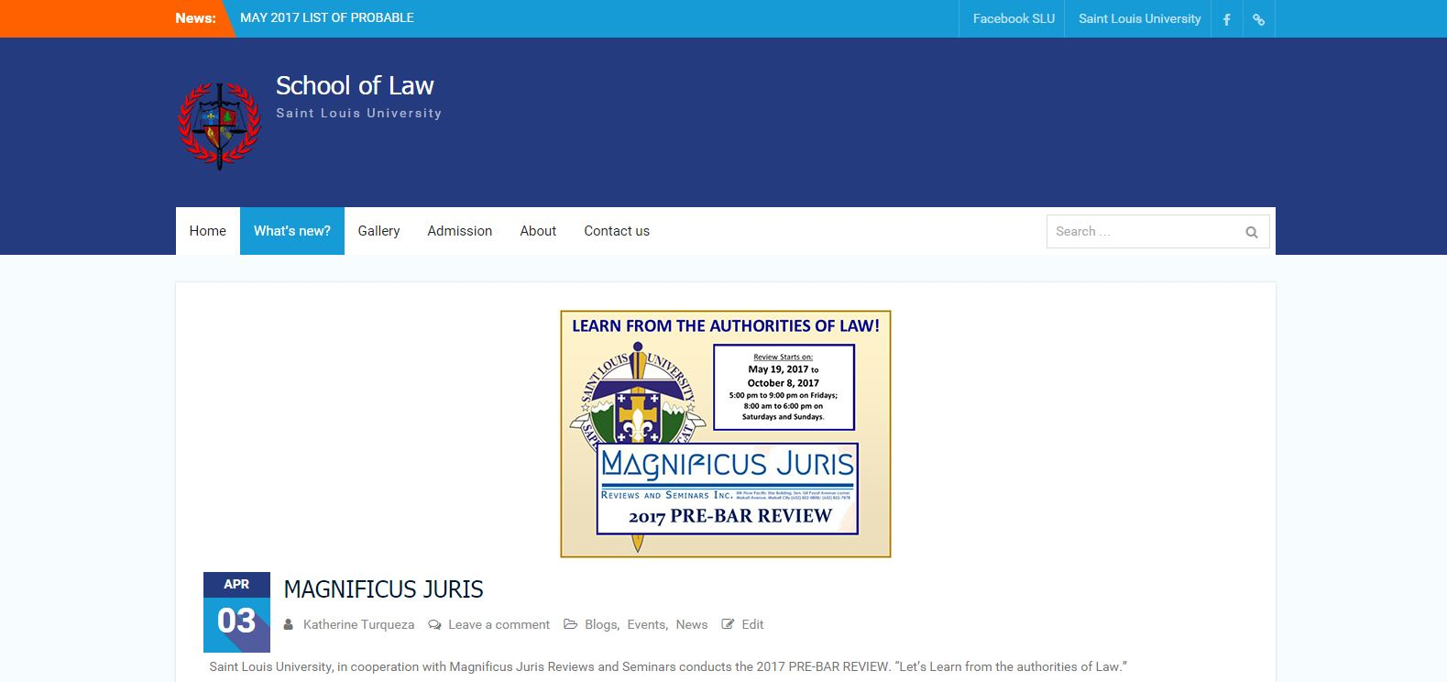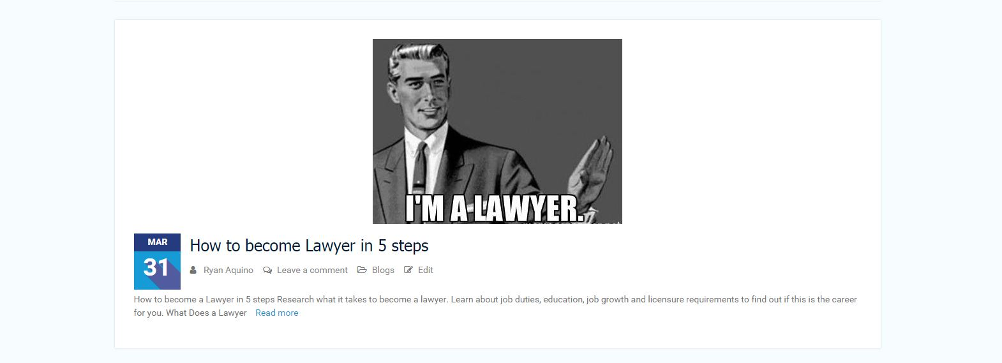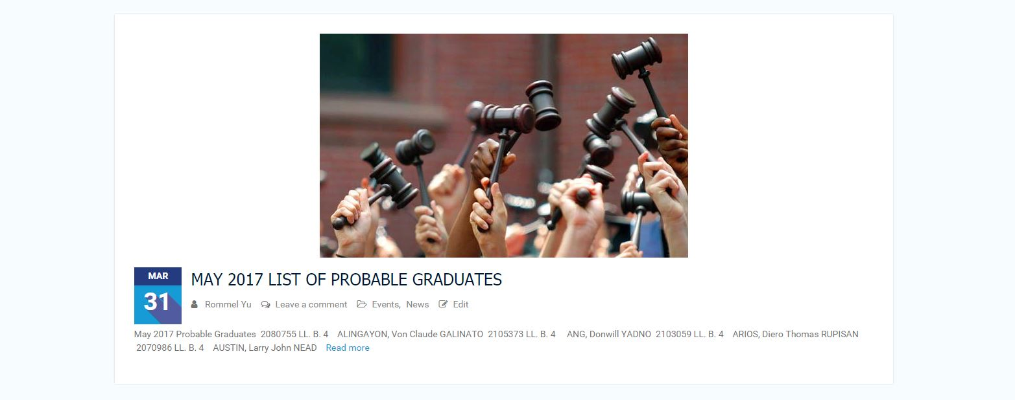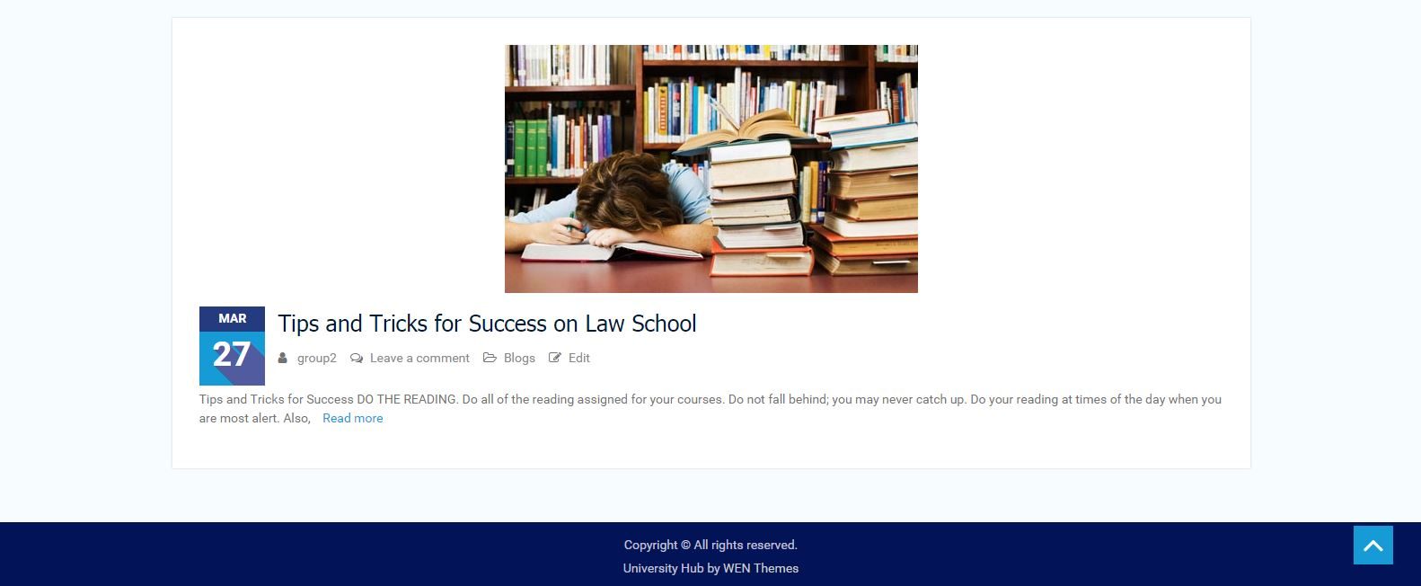Figure 4. Content of the What’s new page.

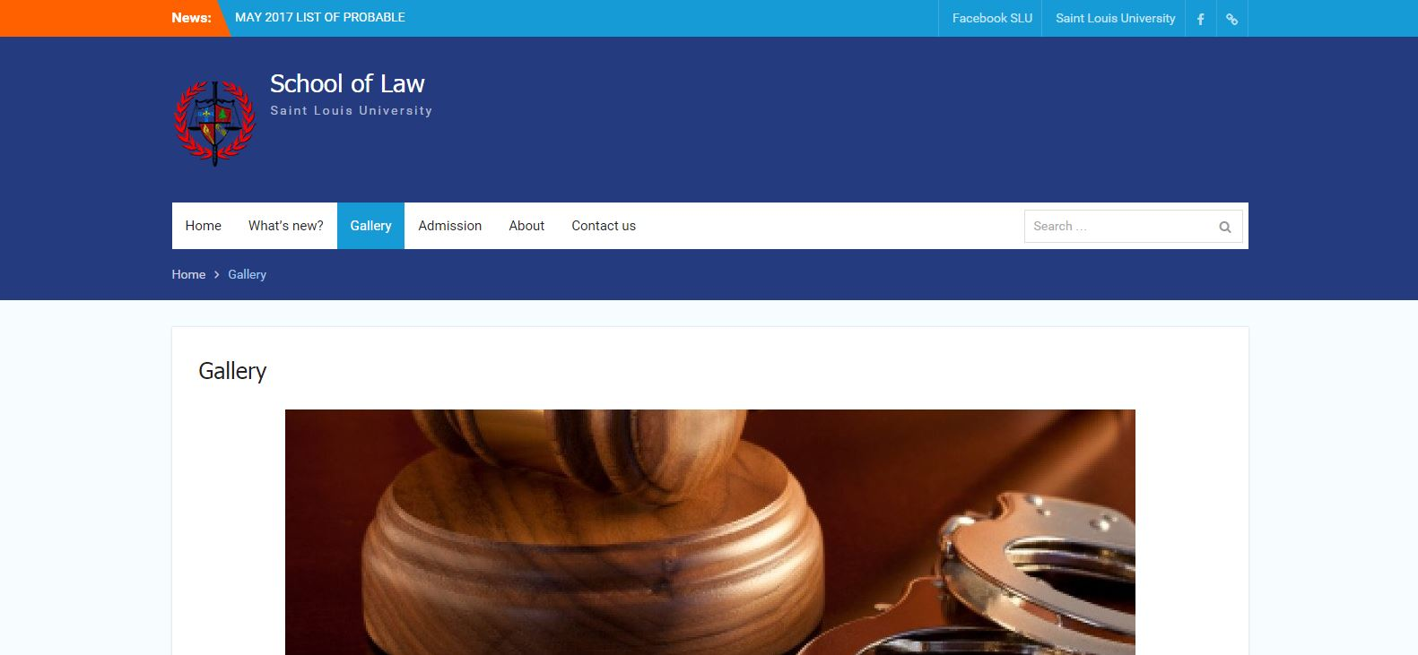

Figure 5. Gallery page.

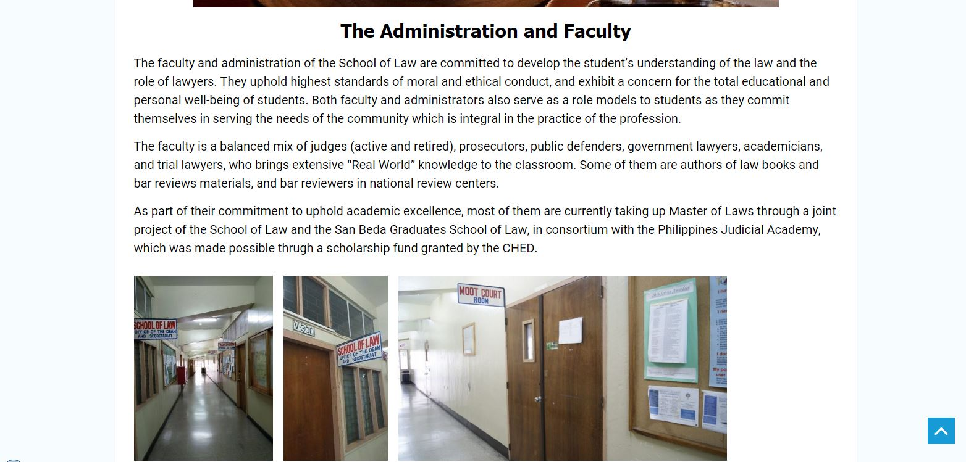

Figure 6. Content of Gallery page.

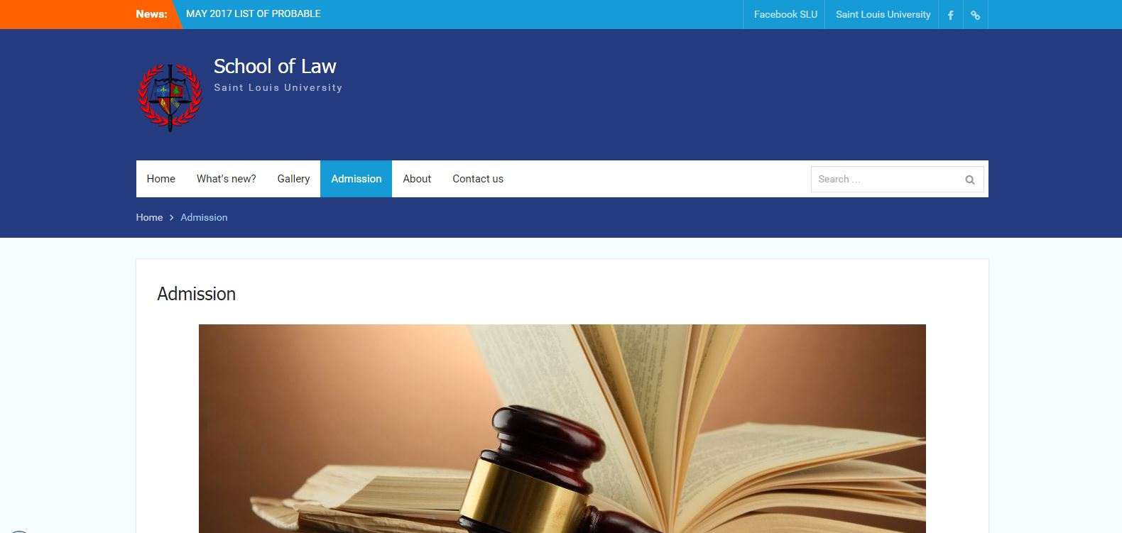

Figure 7. Admission page.

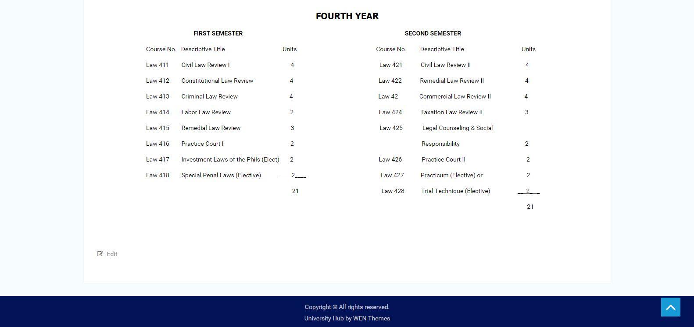

Figure 8. Content of Admission page.

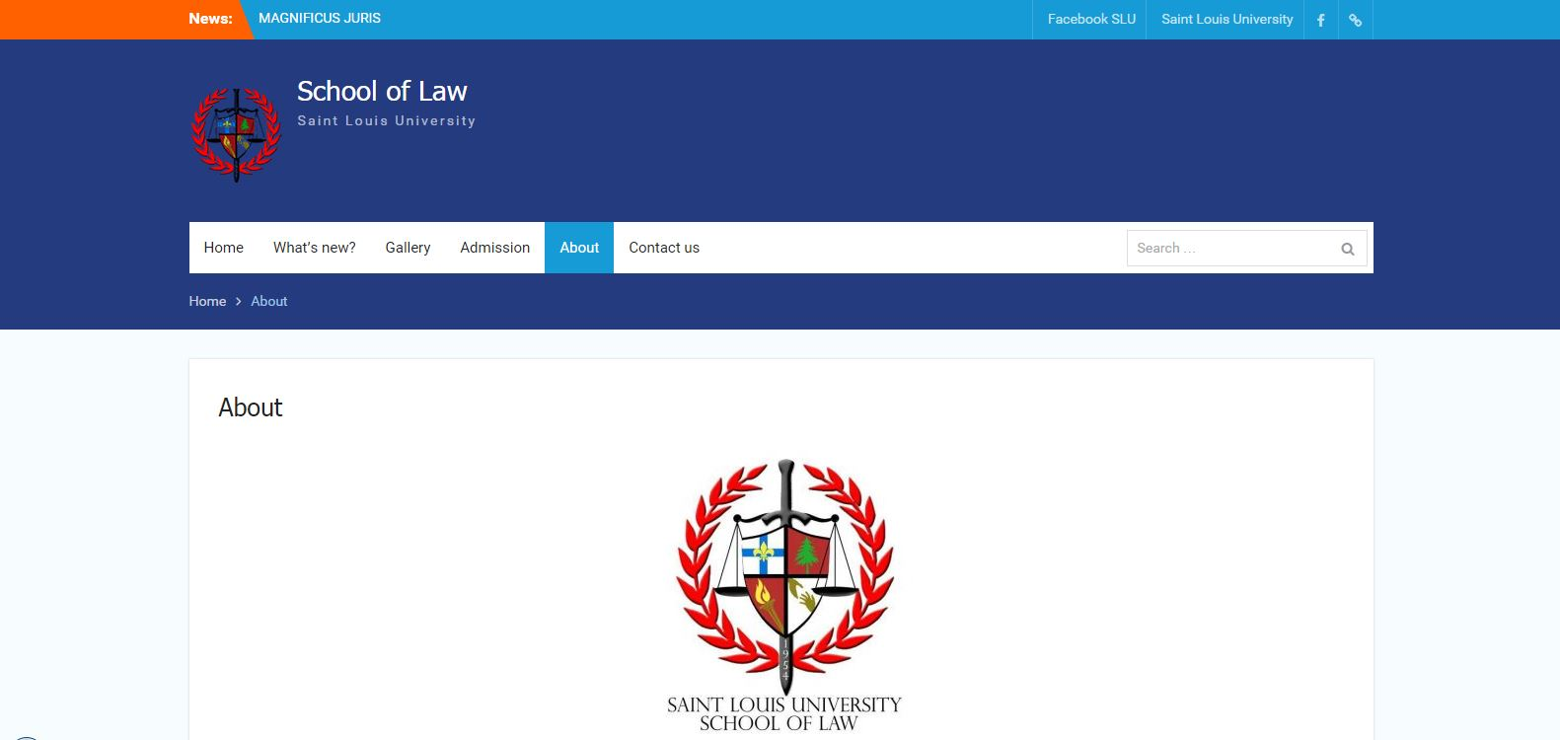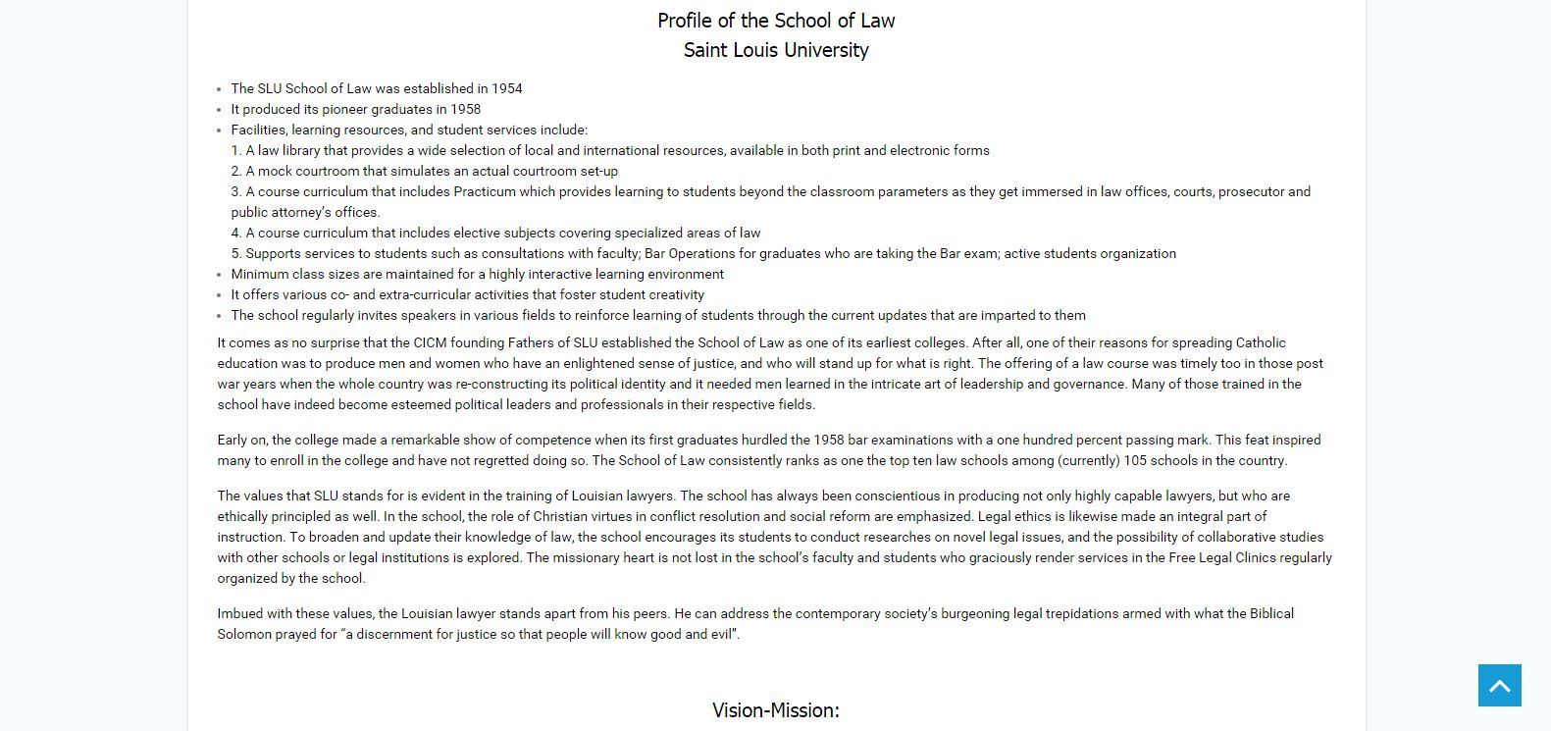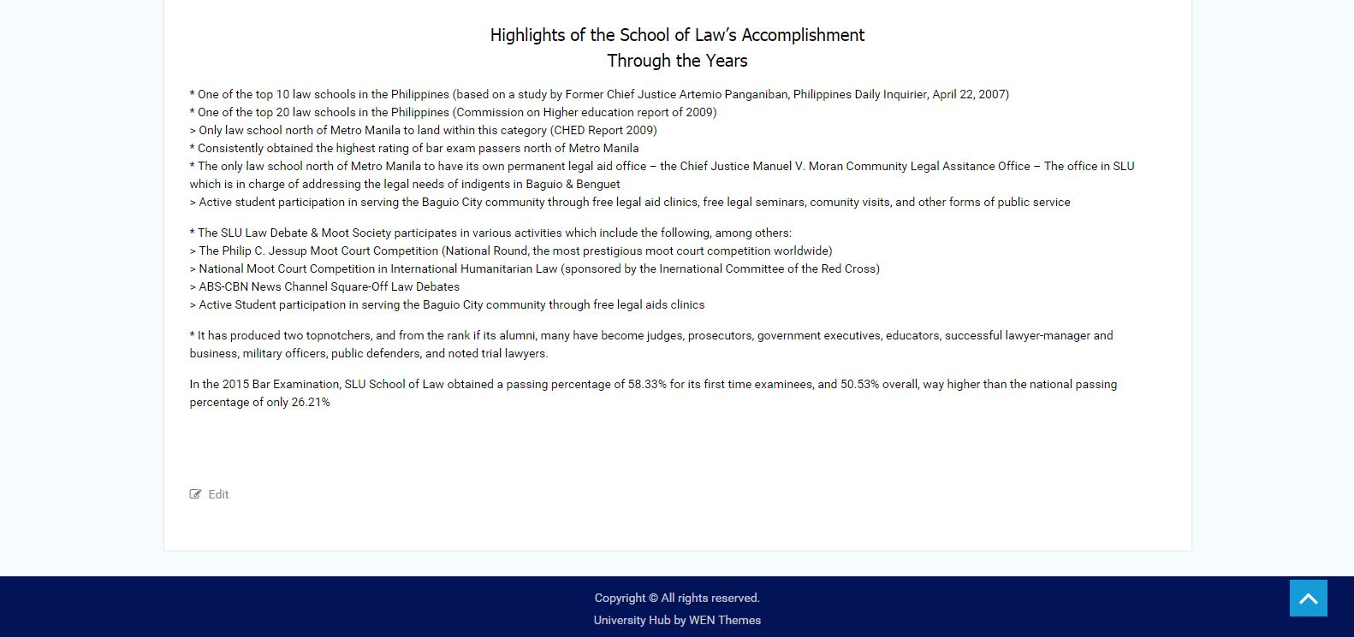

Figure 9. About page and its contents

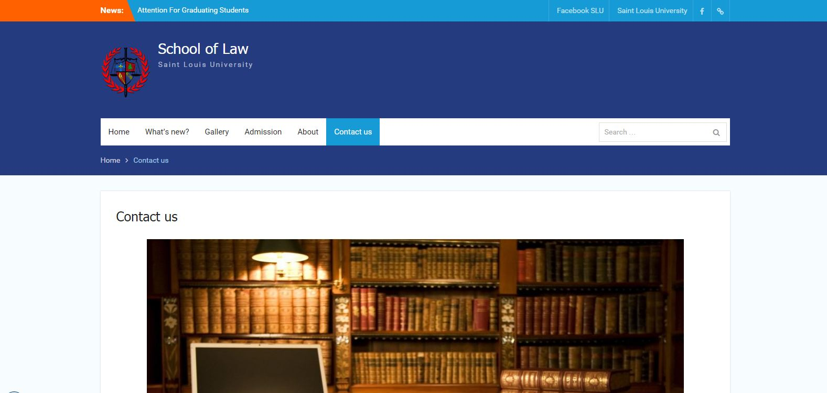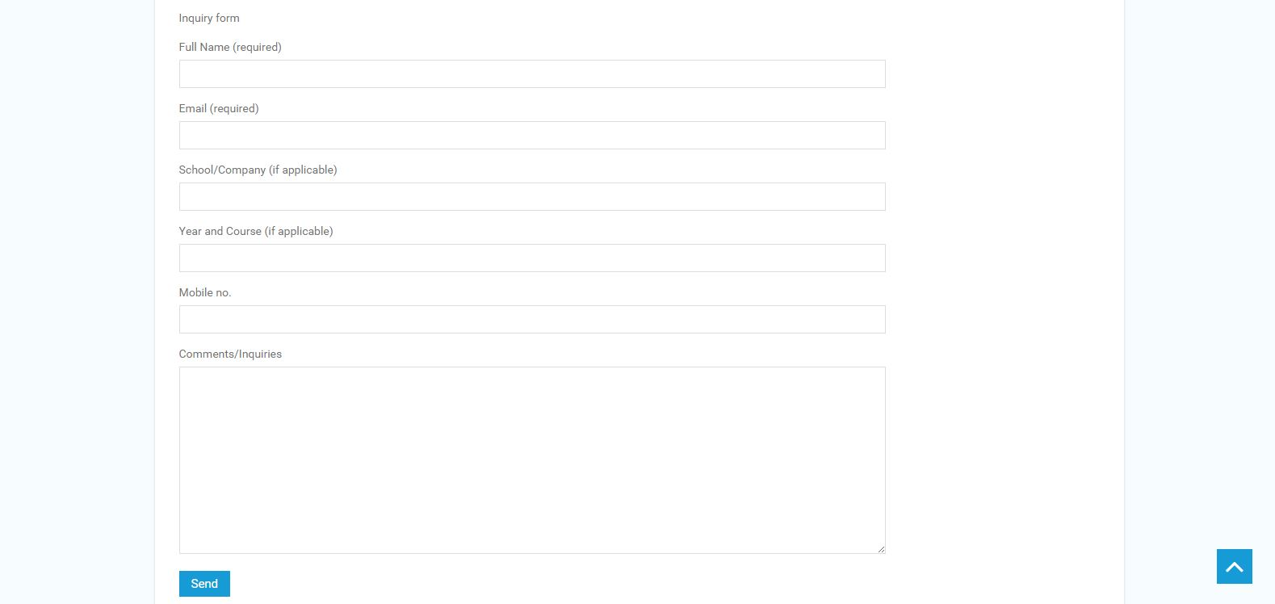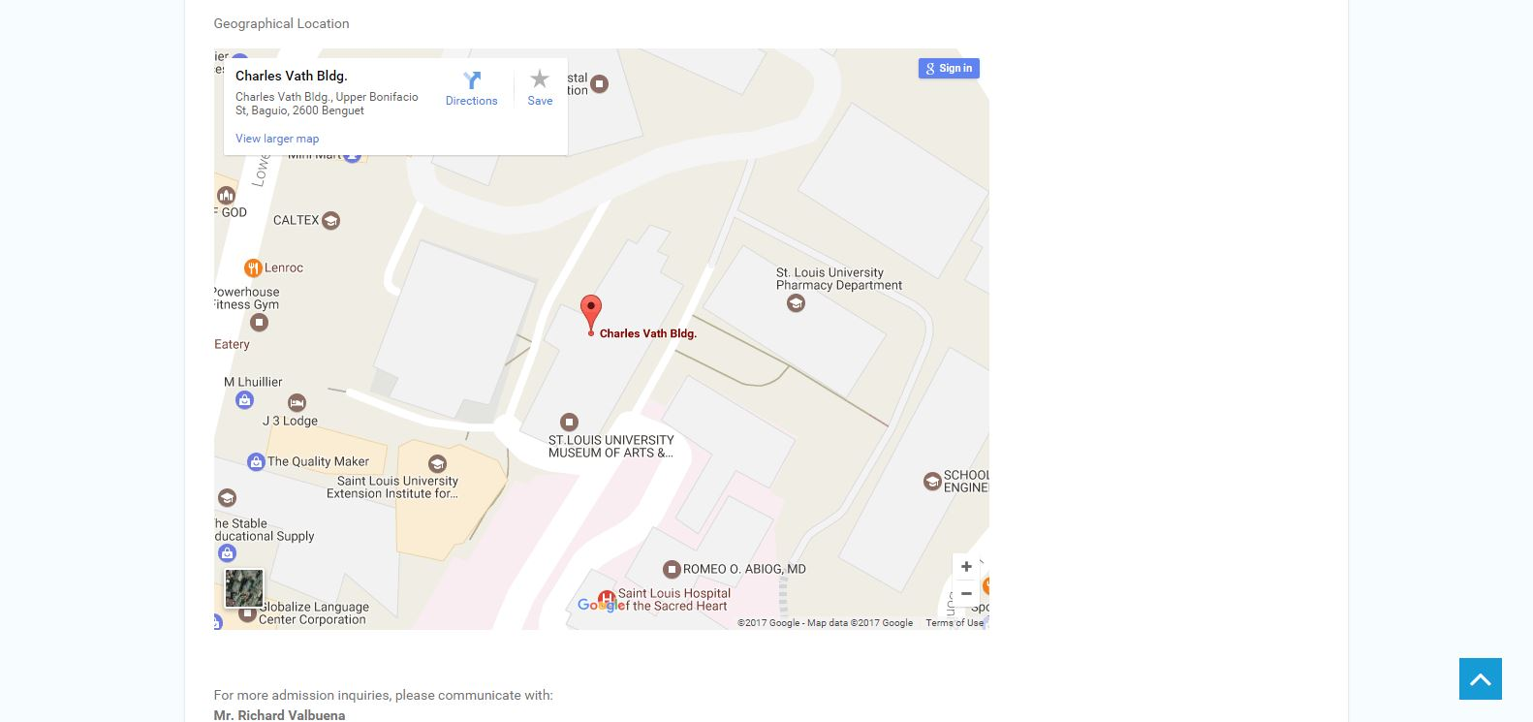

Figure 10. Contact Us page and its contents, with an inquiry form and google map field included.

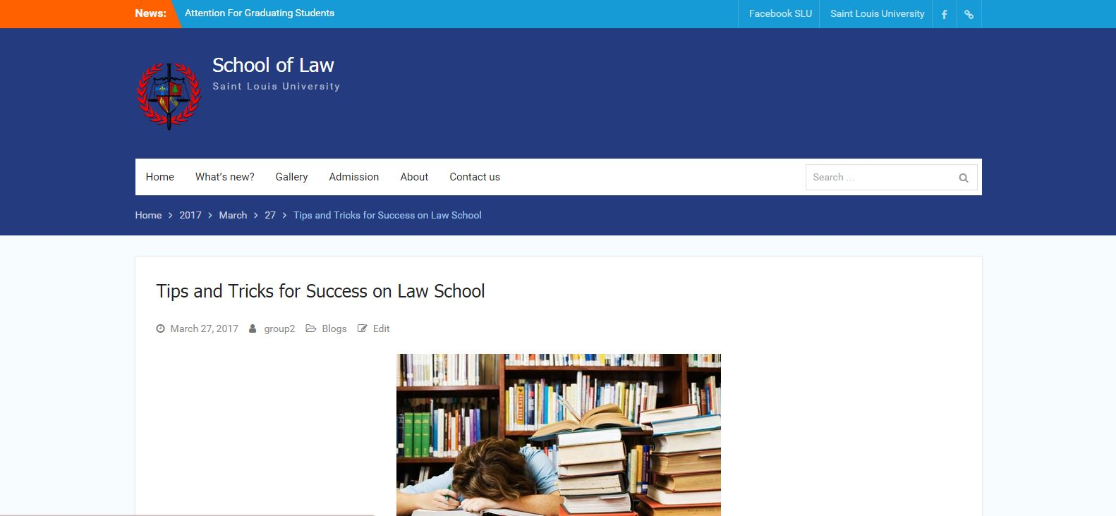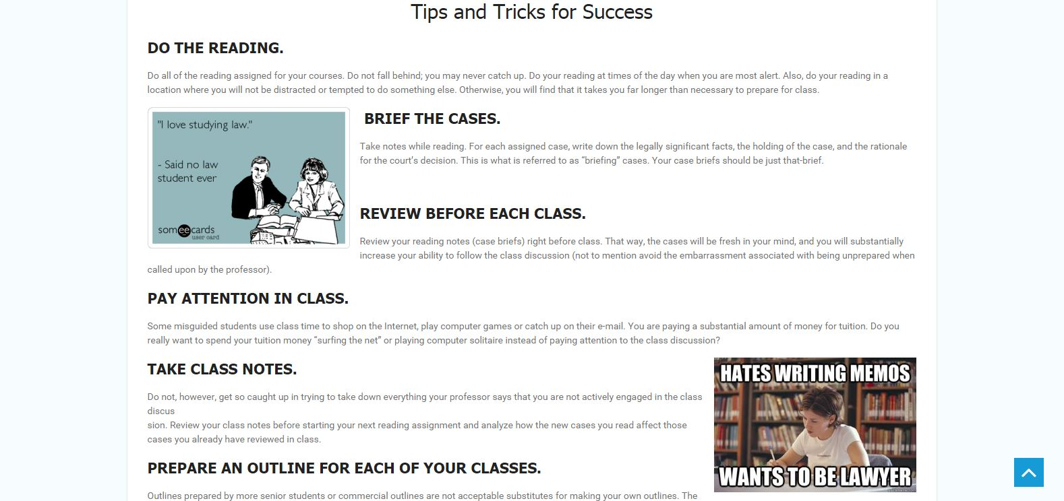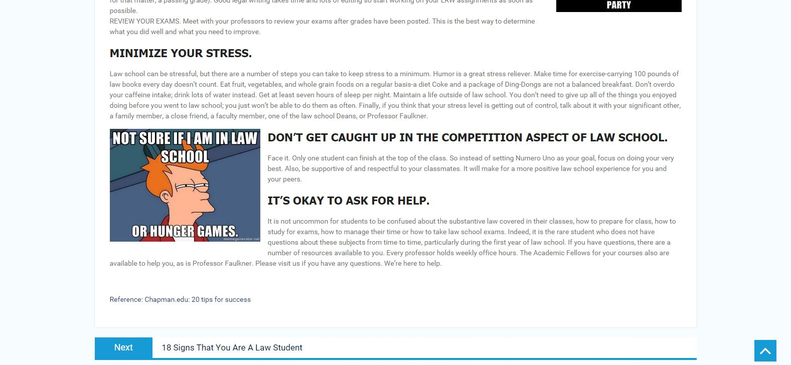

Figure 11. Sample post entitled “Tips and Tricks for Success on Law School”

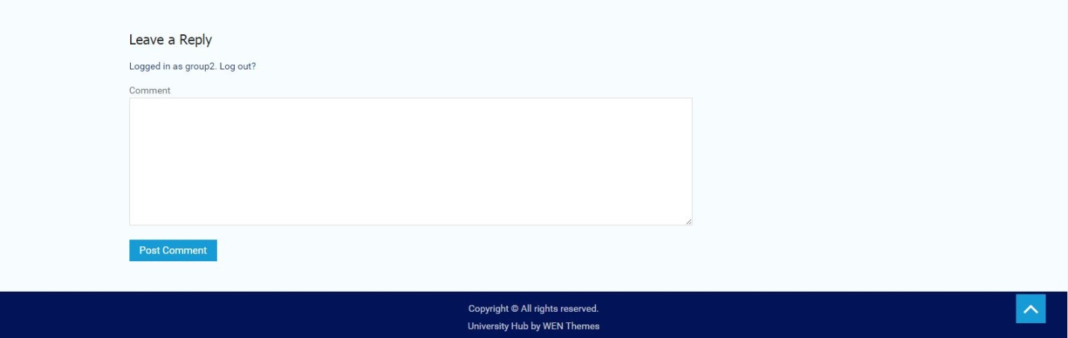

Figure 12. Sample post footer with a reply field for feedbacks or inquiries.

Screenshots of the application with brief description (responsive layout included)